

De La Salle University

College of Computer Studies

Software Technology Department

**GODO PHILIPPINES**

SOFTWARE REQUIREMENTS SPECIFICATION

|  |  |
| --- | --- |
| **Team Name** | **Team Miggy** |
| **Section** | S11 |
| **Team Member** | Castillo, Reneé Dominique M.  Cempron, Jonathan Paul C.  Deogracias, Nolan Matthew T.  Hayakawa, Yuuki V.  Nablo, Juan Paolo J.  Olan, Andrea Michelle M.  Punzalan, Alexander John M.  Tejada, Mima Maiden B.  Torres, Miguel Alfonso C.  Vivo, Roi Emmanuel A. |
| **Date Submitted** | 12 March 2016 |

**Table of Contents**

|  |  |
| --- | --- |
| 1. Executive Summary | 1-1 |
| 1. Overview | 2-1 |
| * 1. Existing Business Process | 2-1 |
| * 1. Data Requirements | 2-2 |
| * 1. Roles in the Business Process | 2-3 |
| 1. Problem Analysis | 3-1 |
| 1. Software Solution | 4-1 |
| * 1. Objectives | 4-1 |
| * 1. Characteristics | 4-1 |
| 1. User Stories | 5-1 |
| * 1. All users can search for an ongoing delivery to evaluate a specific PO given an PO ID | 5-1 |
| * 1. Employee downloads a summary of the delivery monitoring sheet   2. Employee can input information to forms | 5-2  5-3 |
| Appendix A - Improved Business Process | A-1 |
| Appendix B - Interview Transcript | B-1 |
| Appendix C - Sample Forms and Reports | C-1 |
| Appendix D - References and Acknowledgements | D-1 |

1. **Executive Summary**

*GODO is a company that mainly focuses on packaging products for other companies, but mainly customers such as Sony, Bandai, and Fujifilm. The company started in Japan, at 1956, and it has been established in different countries such as Thailand, China, Hong Kong, and Philippines. The company started emerging in the Philippines during 2000, and it has serviced numerous clients for their packaging needs.*

*The business of GODO is to cater the client’s request and needs by finding the “best” supplier. The company then becomes a window for the client company and the product supplier. Their task is relay all the information given by the client regarding the production of the desired product to the chosen supplier, and they will monitor the deliveries of the products from the supplier to the client.*

1. **Overview of the Business Process**

***2.1 Existing Business Process***

*Godo Philippines provides packaging services to companies. It selects highly trusted suppliers to have the packaging orders produced with a budget-friendly price at great quality.*

*The process starts with interested clients who wish to have their products encased in a packaging that may also contain useful documentation that support the product such as manuals. The client asks for a quotation to Godo Philippines on how much the packaging will cost. Godo Philippines will then ask for a quotation as well to their Philippines and China suppliers. Once their suppliers give the quotation, the Marketing Department from Godo Philippines will then give a quotation to the requesting client, that will be approved by the General Manager. The quotation form indicates the product, material to be used for that product, lot quantity that the client requested, and the unit price already quoted by Godo Philippines to the client.*

*Potential clients will of course look for different various packaging companies who also try to win the bidding to get the clients. Once the client rewards the project to Godo Philippines, the client will place a purchasing order to Godo Philippines to finalize their order information. Godo Philippines will also award the project to one of their suppliers. Most of the time, Godo Philippines chooses the supplier with cheaper rates but with precise output. Moreover, Godo Philippines also considers if the supplier can handle additional workload by checking its schedule if they have matching schedule with the client.*

*Once the project is awarded to a supplier, Godo Philippines ensures the materials and components to be used by the supplier. Godo Philippines sends a Material Safety Data Sheet (MSDS) and a Test Report to the client to ensure that the materials and components are Restriction of Hazardous Substances (RoHS) compliant before starting mass production.*

*Once production has started, it is now up to the client’s discretion on when they want their orders delivered. Some clients have their orders delivered all at once. However, most clients want their orders to be delivered frequently in small quantities. For example, the client ordered 10,000 pieces for a paper packaging, some clients want 1,000 to be delivered by next week, 500 on the following week, and so on, until all 10,000 pieces are fulfilled and delivered.*

*First delivery will be made between the supplier and Godo Philippines. The supplier will deliver the ordered materials to Godo Philippines and issues a delivery receipt to the delivery personnel, the delivery receipt does not indicate prices for security purposes. In lieu, prices will be included in the sales invoice which will be directly forwarded to Godo Philippines by the supplier. Second delivery now be made between Godo Philippines and the supplier, same process goes wherein a delivery receipt and a sales invoice will be issued. After every successful delivery, the Quality Assurance from Godo Philippines will keep track of the number of quantity delivered to the client. A delivery monitoring sheet is being updated weekly and monthly.*

*However, errors in production are still possible, some pieces may have deformity that is why Godo Philippines also have a Rejection Form. This form includes the defect and how many pieces should be reproduced. Other necessary information such as Supplier/Subcon name and necessary signatories may be included as well.*

*Once orders are completed, the account is closed.*

*The business process can be visualized in the diagram shown in Figure 2-1.*

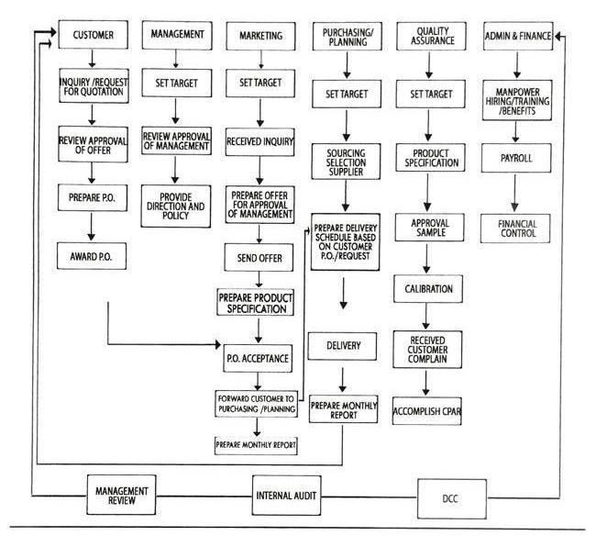

*Figure 2-1. Existing Business Process*

***2.2 Data Requirements***

*A quotation form (see Appendix C-1) is submitted upon the interest of the client in having Godo Philippines as their packaging company contains the following information namely the description/part number of each material to be used, its lot quantity, detailed material information, and unit price. The quotation form also contains the date the quotation is sent, terms, leadtime, validity, and proper signatories. Each quotation form is identified by a unique quotation form number.*

*A purchasing order (see Appendix C-2 and Appendix C-3) that is submitted upon the awarding of the project to Godo Philippines contains the following information namely the client’s information (name, address, telephone number, fax number, and contact person), Godo Philippines’ information (name, address, telephone number, fax number, and contact person and position), delivery information (deliver to and delivery date), payment terms, remarks containing the client’s quotation number, order description, quantity, unit, unit price, amount (unit price X quantity), and purchase order’s total amount. The purchase order also has a date, purchase order number that uniquely identifies the form, and necessary signatories.*

*A delivery receipt (see Appendix C-5) that is given to the delivery personnel upon each delivery contains the following information namely the date, delivery information (delivered to and address), TIN number, terms, quantity, unit, and particulars. The delivery receipt also contains a unique delivery receipt number that uniquely identifies it and necessary signatories. Take note that the delivery receipt has no price indicated due to security purposes.*

*A delivery monitoring sheet (see Appendix C-7) has two classifications: delivery monitoring sheet for supplier, and delivery monitoring sheet for customer. Nonetheless, the delivery monitoring sheet contains the following information namely client name/supplier name, months for a particular period of years (i.e., April 2015-March 2016), and total delayed delivery for each client/supplier. This sheet also contains proper signatories to validate it.*

*A quality complaint feedback report (see Appendix C-8) that is submitted by the client whenever there are defects on the delivered product contains the following information namely supplier/subcon information (name, contact people, from what client, date issued), when was the defect found (outgoing inspection, incoming inspection, in-process inspection, quality system check, or others), reported by, verified & confirmed by, approved by, product name, model number, batch number or lot number, date received, inspection method, sampling plan, affected quantity, defective quantity, date encountered, defective percentage, number of occurrence, failure/defect description, disposition (rework or repair, use as is, replace, return, 100% sorting, or others), nature of request (for information only or submit 8D report), answer (need or no need), date answer required, recipient fill-in, and originator fill-in.*

*A sales invoice (see Appendix C-6) that is submitted to the client upon after every delivery contains the following information namely the date, terms, TIN number, client’s information (name, address, and contact person), quantity, unit, particulars, unit price, amount (unit price X quantity), and total amount. The sales invoice also has a sales invoice number that uniquely identifies it as well as necessary signatories.*

*A summary of billing for each client is also one of the data requirements, it contains the client name, date, materials, date delivered for each material, invoice number for each delivery, quantity delivered for each delivery, total delivery for each material, unit price of each delivery, amount (unit price X quantity) for each delivery, and total amount for each material.*

***2.3 Roles in the Business Process***

*Various employees are involved in the business process of Godo Philippines. The roles of these employees and their tasks are summarized in Table 2-1.*

|  |  |
| --- | --- |
| Role | Description of Tasks |
| *Marketing* | * *Prepares quotation to customer* * *Delivers monthly summary report for both client and supplier* |
| *General Manager* | * *Approves quotation from client* |
| *Quality Assurance* | * *Accepts the delivery of supplier (no defect on the items delivered)* * *Purchasing/Planning staff key in the delivery receipt monitors purchase order (P.O.)* |
| *Customer Invoice Issuance* | * *Issues invoice to customer based on supplier delivery for the month (planning must be at least on the last working day of the month)* |

*Table 2-1. Employee/Department Roles and Tasks in GODO*

**3 Problem Analysis**

|  |  |  |  |
| --- | --- | --- | --- |
| **Description**  What’s the problem? | **Cause**  What causes the problem? | **Symptoms**  How do we know the problem exists? | **Impact**  Why is this important? What are the consequences? |
| No proper system in monitoring the Purchasing Orders from both the client and supplier when product deliveries to client are made. | Purchasing Orders from the client and supplier are done and monitored manually via Microsoft Excel. | The manual process of monitoring the Purchasing Orders causes a lengthy and extensive procedure, which takes more time. | Errors may happen anytime. One error can drastically misinterpret the information being sent to the supplier or client. |
| Godo only uses paper to archive the forms. There are too many papers that are wasted just by printing. An example of this is the weekly and monthly report. | There are no system or database for the files of forms that Godo has. There are also no system to search for the files because everything is on excel only. | Godo has a lot of papers specially the monthly and weekly summary report. | There papers could be destroyed by calamities like earthquake or typhoon. It could take a lot of effort to reprint or get the old files back. |

**4 Software Solution**

**4.1 Objectives**

*The specific objectives of the software are as follows:*

* *The software aims to track and monitor ongoing deliveries of products from the supplier to the client based on their Purchasing Orders*
* *The software aims to store and retrieve data from important documents such as quotation forms, purchase orders, delivery monitoring sheets, delivery receipts, and sales invoice to be used for analysis reports*
* *The software aims to print needed documents based from the data stored regarding quotation forms, purchase orders, delivery monitoring sheets, delivery receipts, and sales invoice with the same format with the original hard copy*
* *The software aims to modify the data that relates to the ongoing delivery whenever discrepancies occur*

**4.2 Characteristics**

* *Easy-access and real-time update of information such as quotation forms (product, lot quantity, material to be used, and unit price), purchase order (item code, product description, size and materials, quantity, unit price, amount), delivery receipt (delivered to, delivery address, date, quantity, unit, particulars), sales invoice (client, client’s address, date, terms, quantity, unit, particulars, unit price, amount, total amount), and delivery monitoring sheet (client/supplier name, number of defects (if any)).*
* *No difficulties in adding, updating and maintaining data of the system.*
* *Produce daily/weekly/monthly delivery report that summarizes all the transactions in that certain time period*
* *Needed documents can be printed using this feature*
* *Data can be exported into a personal computer, and can be evaluated even without the presence of the server.*
* *Data is stored in a local database, wherein only the employees in the branch can access it.*

1. **User Stories**

|  |  |
| --- | --- |
| **User Story #1:** An employee can search for forms (*Purchasing Order, Sales Invoice, Delivery Receipts*). | |
| **Estimate (Days): 1** | **Priority: 10** |
| **Pre-condition:** The system is running and is displaying the main page. | |
| **Scenario:**   1. The employee selects the **“Search Form” tab**. 2. The system displays the following:    1. **drop-down menu** containing the **list of forms available** (Quotation, Purchase Order, Delivery Monitoring, Delivery Receipt, Sales Invoice)    2. **drop-down menu** containing the possible **search keywords** to be used (i.e., form number and client name for purchase orders)    3. **search text box**    4. **search button**    5. **list** 3. The employee selects which form to search via a drop-down menu (Purchasing Order, Quotation, Delivery Monitoring Sheet, etc). 4. The employee selects which keyword to use for searching via a drop-down menu (form number, client name, supplier name, etc). 5. The employee inputs the search keyword. 6. The system displays the results based on the previous inputs. 7. The employee can select on a result by clicking it. 8. The employee can afterwards click on the **“View” button** located below the search results list. | |
| **Post-condition:**  The employee was able to view the form. | |
| **Acceptance Criteria:**   1. The system should be able to display the **“Search Form” tab**. 2. The system should be able to display the forms that can be searched through drop-down menu. 3. The system should disable the second drop-down menu (containing the possible search keywords of the form) if there is no selected entry in the first drop-down menu. 4. The system should display the correct search keywords based on the selected form from the first drop-down menu. 5. The system should verify if the form (based on the input) exists in the database.    1. If not, the system should prompt the user to input again. 6. Once the inputs are all valid, the system should display the correct search results. 7. If the employee chooses to view a search result, the system should display the correct information of the selected form. | |

|  |  |
| --- | --- |
| **User Story #2:** An employee can add *Customer Purchasing Order (PO) Forms* into the database. | |
| **Estimate (Days): 1** | **Priority: 10** |
| **Pre-condition:**  The system is running and is displaying the main page. | |
| **Scenario:**   1. The employee selects the **“Customer Purchase Order” tab**. 2. The employee selects the **“Add Purchase” button**. 3. A pop-up window appears and the employee enters data in all necessary fields (Customer PO number, Customer Name, Date Issued, Expected Delivery Date, and Ordered Items - which has respective attributes as well). 4. The system asks the user if all information entered are correct and final. 5. The employee confirms the data and the form to be added. 6. The system displays that saving the form was successful. | |
| **Post-condition:**  The system saves the form into the database and should be available for viewing in the system. | |
| **Acceptance Criteria:**   1. The system should show the main page and the tabs. 2. The employee should be able to select tab of the form to update. 3. The employee should be able to click the **“Add” button**. 4. The system should be able to properly display the pop-up window for **“Add”**. 5. The employee should be able to type in all the data in the necessary fields. 6. The system should ask the employee if all the entered information are correct and final. 7. The system should verify if the form number does not exist yet. 8. The system should let the employee fix the information entered if there are any errors. 9. The system should successfully save the form in the database. 10. The employee should be able to view the form under the **“Customer Purchase Order”** tab. | |

|  |  |
| --- | --- |
| **User Story #3:** An employee can add *Supplier Purchasing Order (PO) Forms* into the database. | |
| **Estimate (Days): 1** | **Priority: 10** |
| **Pre-condition:**  The system is running and is displaying the main page. | |
| **Scenario:**   1. The employee selects the **“Supplier Purchase Order” tab**. 2. The employee selects the **“Add Purchase Order” button**. 3. A pop-up window appears and the employee enters data in all necessary fields (Supplier PO number, Customer PO number, Supplier Name, Date Issued, and Expected Delivery Date). 4. The system asks the user if all information entered are correct and final. 5. The employee confirms the data and the form to be added. 6. The system displays that saving the form was successful. | |
| **Post-condition:**  The system saves the form into the database and should be available for viewing in the system. | |
| **Acceptance Criteria:**   1. The system should show the main page and tabs. 2. The employee should be able to select tab of the form to update. 3. The employee should be able to click the **“Add” button**. 4. The system should be able to properly display the pop-up window for **“Add”**. 5. The employee should be able to type in all the data in the necessary fields. 6. The system should ask the employee if all the entered information are correct and final. 7. The system should verify if the form number does not exist yet. 8. The system should let the employee fix the information entered if there are any errors. 9. The system should successfully save the form in the database. 10. The employee should be able to view the form under the **“Supplier Purchase Order”** tab. | |

|  |  |
| --- | --- |
| **User Story #4:** An employee can add *Delivery Receipts* into the database. | |
| **Estimate (Days): 1** | **Priority: 10** |
| **Pre-condition:**  The system is running and is displaying the main page. | |
| **Scenario:**   1. The employee selects the **“Delivery Receipt”** **tab**. 2. The employee selects the **“Add” button**. 3. A pop-up window appears and the employee enters data in all necessary fields (Delivery Receipt Number, Supplier PO Number, and Date Received). 4. The system asks the user if all information entered are correct and final. 5. The employee confirms the data and the form to be added. 6. The system displays that saving the form was successful. | |
| **Post-condition:**  The system saves the form into the database and should be available for viewing in the system. | |
| **Acceptance Criteria:**   1. The system should show the main page. 2. The system should be able to display the tabs and its sub-tabs. 3. The employee should be able to select tab of the form to update. 4. The employee should be able to click the **“Add” button**. 5. The system should be able to properly display the pop-up window for **“Add”**. 6. The employee should be able to type in all the data in the necessary fields. 7. The system should ask the employee if all the entered information are correct and final. 8. The system should verify if the form number does not exist yet. 9. The system should let the employee fix the information entered if there are any errors. 10. The system should successfully save the form in the database. 11. The employee should be able to view the form in the **“Delivery Receipt”** tab. | |

|  |  |
| --- | --- |
| **User Story #5:** An employee can add *Sales Invoice Forms* into the database. | |
| **Estimate (Days): 1** | **Priority: 10** |
| **Pre-condition:**  The system is running and is displaying the main page. | |
| **Scenario:**   1. The employee selects the **“Sales Invoice”** **tab**. 2. The employee selects the **“Add” button**. 3. A pop-up window appears and the employee enters data in all necessary fields (Invoice Number, Delivery Receipt Number, Customer PO Number, Customer Name, Price, and Date Received). 4. The system asks the user if all information entered are correct and final. 5. The employee confirms the data and the form to be added. 6. The system displays that saving the form was successful. | |
| **Post-condition:**  The system saves the form into the database and should be available for viewing in the system. | |
| **Acceptance Criteria:**   1. The system should show the main page and tabs. 2. The employee should be able to select tab of the form to update. 3. The employee should be able to click the **“Add” button**. 4. The system should be able to properly display the pop-up window for **“Add”**. 5. The employee should be able to type in all the data in the necessary fields. 6. The system should ask the employee if all the entered information are correct and final. 7. The system should verify if the form number does not exist yet. 8. The system should let the employee fix the information entered if there are any errors. 9. The system should successfully save the form in the database. 10. The employee should be able to view the in the **“Sales Invoice”** tab. | |

|  |  |
| --- | --- |
| **User Story #6:** An employee can update and modify a *Customer Purchasing Order (PO) Form*. | |
| **Estimate (Days):** | **Priority: 10** |
| **Pre-condition:** The system is running and is displaying the main page. | |
| **Scenario:**   1. The employee selects the **“Customer Purchase Order” tab**. 2. The employee selects which form to edit and this form will be highlighted. 3. The employee clicks the **“Update Purchase Order” button** - which will result to a pop-up window. 4. The employee inputs the data in the necessary fields to be modified. 5. The employee clicks the **“Save” button**. 6. The system asks the employee for confirmation. 7. The employee confirms the finalized revisions. 8. The system displays that saving the form was successful. | |
| **Post-condition:** The system saves the modifications/revisions of the form. | |
| **Acceptance Criteria:**   1. The system should show the main page. 2. The system should be able to display the tabs and its sub-tabs. 3. The employee should be able to select tab of the form to update. 4. The employee should be able to click the **“Update” button**. 5. The system should be able to properly display the pop-up window for **“Update”**. 6. The employee should be able to type in all the data in the necessary fields. 7. The system should ask the employee if all the entered information are correct and final. 8. The system should verify if the project of the form is still open. If not, the system should display an error message regarding the restriction of editing closed project forms. 9. The system should let the employee fix the information entered if there are any errors. 10. The system should display error message(s) if the entered format is invalid. 11. The system should successfully save the form in the database. 12. The employee should be able to view the updated form under the **“Customer Purchase Order”** tab. | |

|  |  |
| --- | --- |
| **User Story #7:** An employee can update and modify a *Supplier Purchasing Order (PO) Form*. | |
| **Estimate (Days):** | **Priority: 10** |
| **Pre-condition:** The system is running and is displaying the main page. | |
| **Scenario:**   1. The employee selects the **“Supplier Purchase Order” tab**. 2. The employee selects which form to edit and this form will be highlighted. 3. The employee clicks the **“Update” button** - which will result to a pop-up window. 4. The employee inputs the data in the necessary fields to be modified. 5. The employee clicks the **“Save” button**. 6. The system asks the employee for confirmation. 7. The employee confirms the finalized revisions. 8. The system displays that saving the form was successful. | |
| **Post-condition:** The system saves the modifications/revisions of the form. | |
| **Acceptance Criteria:**   1. The system should show the main page. 2. The system should be able to display the tabs and its sub-tabs. 3. The employee should be able to select tab of the form to update. 4. The employee should be able to click the **“Update” button**. 5. The system should be able to properly display the pop-up window for **“Update”**. 6. The employee should be able to type in all the data in the necessary fields. 7. The system should ask the employee if all the entered information are correct and final. 8. The system should verify if the project of the form is still open. If not, the system should display an error message regarding the restriction of editing closed project forms. 9. The system should let the employee fix the information entered if there are any errors. 10. The system should display error message(s) if the entered format is invalid. 11. The system should successfully save the form in the database. 12. The employee should be able to view the updated form under the **“Supplier Purchase Order”** tab. | |

|  |  |
| --- | --- |
| **User Story #8:** An employee can update and modify a *Delivery Receipt*. | |
| **Estimate (Days):** | **Priority: 10** |
| **Pre-condition:** The system is running and is displaying the main page. | |
| **Scenario:**   1. The employee selects the **“Delivery Receipt”** **tab**. 2. The employee selects which form to edit and this form will be highlighted. 3. The employee clicks the **“Update” button** - which will result to a pop-up window. 4. The employee inputs the data in the necessary fields to be modified. 5. The employee clicks the **“Save” button**. 6. The system asks the employee for confirmation. 7. The employee confirms the finalized revisions. 8. The system displays that saving the form was successful. | |
| **Post-condition:** The system saves the modifications/revisions of the form. | |
| **Acceptance Criteria:**   1. The system should show the main page. 2. The system should be able to display the tabs and its sub-tabs. 3. The employee should be able to select tab of the form to update. 4. The employee should be able to click the **“Update” button**. 5. The system should be able to properly display the pop-up window for **“Update”**. 6. The employee should be able to type in all the data in the necessary fields. 7. The system should ask the employee if all the entered information are correct and final. 8. The system should verify if the project of the form is still open. If not, the system should display an error message regarding the restriction of editing closed project forms. 9. The system should let the employee fix the information entered if there are any errors. 10. The system should display error message(s) if the entered format is invalid. 11. The system should successfully save the form in the database. 12. The employee should be able to view the updated form under the **“Delivery Receipt”** tab. | |

|  |  |
| --- | --- |
| **User Story #9:** An employee can update and modify a *Sales Invoice Form*. | |
| **Estimate (Days):** | **Priority: 10** |
| **Pre-condition:** The system is running and is displaying the main page. | |
| **Scenario:**   1. The employee selects the **“Sales Invoice”** **tab**. 2. The employee selects which form to edit and this form will be highlighted. 3. The employee clicks the **“Update” button** - which will result to a pop-up window. 4. The employee inputs the data in the necessary fields to be modified. 5. The employee clicks the **“Save” button**. 6. The system asks the employee for confirmation. 7. The employee confirms the finalized revisions. 8. The system displays that saving the form was successful. | |
| **Post-condition:** The system saves the modifications/revisions of the form. | |
| **Acceptance Criteria:**   1. The system should show the main page. 2. The system should be able to display the tabs and its sub-tabs. 3. The employee should be able to select tab of the form to update. 4. The employee should be able to click the **“Update” button**. 5. The system should be able to properly display the pop-up window for **“Update”**. 6. The employee should be able to type in all the data in the necessary fields. 7. The system should ask the employee if all the entered information are correct and final. 8. The system should verify if the project of the form is still open. If not, the system should display an error message regarding the restriction of editing closed project forms. 9. The system should let the employee fix the information entered if there are any errors. 10. The system should display error message(s) if the entered format is invalid. 11. The system should successfully save the form in the database. 12. The employee should be able to view the updated form under the **“Sales Invoice”** tab. | |

|  |  |
| --- | --- |
| **User Story #10:** An employee can view *Customer Purchase Order (PO) Forms*. | |
| **Estimate (Days):** | **Priority: 10** |
| **Pre-condition:** The system is running and is displaying the main page. | |
| **Scenario:**   1. The employee selects the **“Customer Purchase Order” tab**. 2. The system displays all the existing Customer Purchase Order Forms. | |
| **Post-condition:** The employee was able to view all the pending/existing Customer Purchase Order Forms. | |
| **Acceptance Criteria:**   1. The system should be able to display the main page. 2. The system should be able to display the **“Customer Purchase Order” tab**. 3. The system should be able to display all the existing forms available in the database. | |

|  |  |
| --- | --- |
| **User Story #11:** An employee can view *Supplier Purchase Order (PO) Forms*. | |
| **Estimate (Days):** | **Priority: 10** |
| **Pre-condition:** The system is running and is displaying the main page. | |
| **Scenario:**   1. The employee selects the **“Supplier Purchase Order” tab**. 2. The system displays all the existing Supplier Purchase Order Forms. | |
| **Post-condition:** The employee was able to view all the pending/existing Supplier Purchase Order Forms. | |
| **Acceptance Criteria:**   1. The system should be able to display the main page. 2. The system should be able to display the **“Supplier Purchase Order” tab**. 3. The system should be able to display all the existing forms available in the database. | |

|  |  |
| --- | --- |
| **User Story #12:** An employee can view *Sales Invoice Forms*. | |
| **Estimate (Days):** | **Priority: 10** |
| **Pre-condition:** The system is running and is displaying the main page. | |
| **Scenario:**   1. The employee selects the **“Sales Invoice” tab**. 2. The system displays all the open Sales Invoice Forms. | |
| **Post-condition:** The employee was able to view all the pending/existing Sales Invoice Forms. | |
| **Acceptance Criteria:**   1. The system should be able to display the main page. 2. The system should be able to display the **“Sales Invoice” tab**. 3. The system should be able to display all the existing forms available in the database. | |

|  |  |
| --- | --- |
| **User Story #13:** An employee can view *Delivery Receipts*. | |
| **Estimate (Days):** | **Priority: 10** |
| **Pre-condition:** The system is running and is displaying the main page. | |
| **Scenario:**   1. The employee selects the **“Delivery Receipt” tab**. 2. The system displays all the open Delivery Receipt Forms. | |
| **Post-condition:** The employee was able to view all the pending/existing Delivery Receipt Forms. | |
| **Acceptance Criteria:**   1. The system should be able to display the main page. 2. The system should be able to display the **“Delivery Receipt” tab**. 3. The system should be able to display all the existing forms available in the database. | |

|  |  |
| --- | --- |
| **User Story #14:** An employee can download/export a summary of the *delivery monitoring sheet*. | |
| **Estimate (Days): 1** | **Priority: 10** |
| **Pre-condition:** The system is running and is displaying the main page. | |
| **Scenario:**   1. The employee selects the **“Delivery Monitoring Sheet” tab**. 2. The employee selects the **“Download” sub-tab**. 3. The employee selects which type of summary to search and download - yearly or monthly. 4. If the previous input is:    1. yearly, the employee selects the year.    2. monthly, the employee selects the year then selects the month. 5. The system displays the delivery monitoring sheet corresponding to the previous inputs (month and/or year). 6. The employee clicks the **“Download” button**. | |
| **Post-condition:**  The Delivery Monitoring Sheet has been downloaded. | |
| **Acceptance Criteria:**   1. The system should display the **“Delivery Monitoring Sheet” tab**. 2. The system should display the **“Download” sub-tab.** 3. If the user’s input for search is:    1. yearly, the system should not display the current year in the choices.    2. monthly, the system should not display the current month of the current year in the choices. 4. The system should display the correct information of the delivery monitoring sheet based on the previous input/s. 5. The system should be able to export the delivery monitoring sheet to the user’s computer after clicking the **“Download” button**. 6. The employee should be able to view the proper summary of the delivery monitoring sheet in Microsoft Excel. | |

Notes:

* The scenario should provide the sequence of interaction between the user and the system based on valid inputs.
* There should be no mention of interface details (such as screen, buttons, clickable, presses) or platforms (web) anywhere in the user story (including pre- and post-conditions, scenario and acceptance criteria).
* Pre-conditions must state the constraints (on user roles, data availability) that must hold true before the user story can be performed.
* Post-conditions must state the outcome (on data, process, and user state) that will hold true when the user story has been performed.

**Appendix A – Improved Business Process**

*This chapter presents the improved business process when the proposed software solution is implemented. This visualizes how the software solution benefits or affects the current business process.*

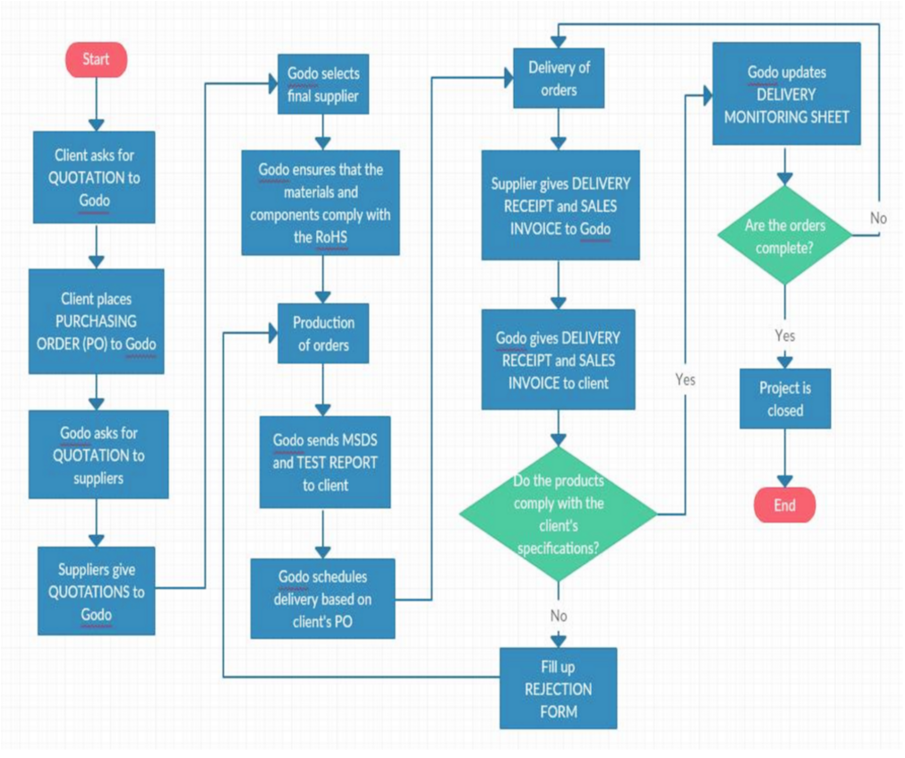

**Appendix B – Interview Transcript**

*Miss Sandra T. Deogracias of Godo Philippines*

[I] - Interviewer

[GD] - Godo Philippines

I: Can you describe the usual business process you do?

GD: So ‘yong sa other branches, we do buying and selling. So sa head office which is in Japan, we have factory for printing and boxes talaga. So usually si Godo kasi follows the Sony factory and ‘yong mga *[inaudible]* nila the one doing earphones ‘yon. So kaya nanganak si Godo Philippines 14 years ago, I think, because of the *[inaudible]* of Sony.

So for Philippines site, so what we do here– so among other companies like ie-example ko na lang ‘yong the recent, the newly, customer of Godo Philippines, okay, so si Fuji. So si Fuji, we *[inaudible]* to Fujifilms which is located in Laguna. So we introduced our company, *we are Godo*, we are a packaging company *bla bla bla*. So the Japanese said “okay can I ask for a quotation for this box” then usually they will give– the customer will give us the quantity requirement kasi different quantity have different prices. So like sige, Fuji said, “quote me 50,000 and 100,000 for this box”.

So what we did, we ask our China suppliers and Philippines suppliers, at the minimum at least 2 suppliers although may database na din kami of the suppliers. Suppliers for the box, suppliers for *[inaudible]*, for plastic, *bla bla bla*. So nakuha ko na ‘yong quotation ng suppliers ko, so pinili ko ‘yong which one is lower, which is the in precision in passing. So nag-quote na ako, so sabi ko kay– si supplier ko, “okay quote me this box”, so nakuha ko na ‘yong quotation, so ito ‘yong isang supplier ko si Precision. Okay, so nag-quote na siya so gumawa na ako ng costing sheet here. So cinost ko siya and then I submit a quotation to my customer. So, nag-quote na ako sa customer ko, so quinote ko na si Fuji na itong box na ‘to is this price for the lot 50,000 and 100,000. Okay? So napunta na sa customer which is si Fuji. Okay?

So si Fuji also have different options, si Godo, si company A, company B, company C. I’m sure kino- compare din nila ‘yong price namin compared to other companies in the Philippines. So until, finally, they awarded the packaging to Godo. Okay. So, I think doon magsisimula ‘yong group niyo for your project.

Okay. So finally, si Fuji issue a purchase order to Godo. Okay? So nagpasok na, Fujifilm issued a purchase order to Godo– to Godo Philippines for this item. So may prod– so ang ida-database– what we need to do is to create all the existing product namin, ni Godo. So like for example, ipapasok mo sa database si instruction manual box with part number– so may product description and part name, okay, tapos quantity. So namili na sa’min– nag-purchase na sa’min si Fuji.

Okay. So, ngayon since mayroon na akong order, so io-order ko ito sa supplier ko kung saan ko in-award ‘yong mga ito *[pertaining to the lists of materials to be used]* like for this PO *[purchase order]*, I have two suppliers. So ipapasok ko ‘to sa PO masterlist at now we are currently using *[Microsoft]* Excel lang so ipapasok namin ito, PO number *YBBBB*, ‘yan ganyan. Okay, tapos meron akong window na pupuntahan na supplier’s purchase order that will match this PO. Okay, so like for this one– so nag-issue na ako ng PO, covering this PO. So this is com– customer PO then I have supplier’s PO. Okay, so sasabihin ko kay supplier, please deliver 10,000 of this item by this date. In most cases, ‘yong 10,000 is also naka-breakdown, customer wants only 500 on this date, 500 on this date. So, bibigyan namin ng instructions si supplier, deliver this much by this date. So pag nag-deliver naman si supplier, so may DR na siya, delivery receipt, okay. So may delivery receipt na siya, so ito ‘yong covering PO namin, so ito galing kay Fuji papunta sa Godo Philippines, ito Godo Philippines papunta sa supplier namin na si Dolmar Press, ‘yan. So ito nagma-match sa dito– usually one is– per item, one PO.

‘Yan, okay, so si Godo Philippines nag-order na sa mga suppliers namin ng different items na pumasok, na bibilhin sa amin. So may bumibili sa amin, kami naman, bibili. Okay, so ngayon, sabi ko, okay deliver– “Dolmar Ink can you deliver this much to Fuji”, so meron naman siyang delivery receipt and covering invoice. So pag nag-deliver naman ‘yong supplier ko, so dapat pupunta ako doon sa window na delivery that will deduct to my 10,000. Halimbawa, si Dolmar nag-deliver ng 500 sa January– halimabawa, nag-deliver siya ngayon, January 22 for example– so ‘yong 10,000 will become 9,500 na naka-link din sa Fuji PO.

I: So, do you update it po after every deduction?

GD: So ngayon, what we did– what we are doing now kasi it’s a manual monitoring. Ah ito *[pertaining to a delivery monitoring sheet]*, like for this one– so naka-Excel lang kami ngayon kasi wala naman kaming system. So for example, this company, si IDC Philippines, Japanese nito is Chihaya, so ito ‘yong mga orders namin, okay? So nag-deliver siya nung January 12 this much with this sales invoice, so manually lang kami nagde-deduct, Excel.

I: Pati write din *[handwritten]*, or talagang lahat sa Excel?

GD: Sorry?

I: Sinusulat?

GD: Ah, minsan sinusulat. ‘Yon kasi sayang kung every ano– tapos nagpi-print eh para we’re saving. So parang, ngayon, ang system namin, is on a weekly, or weekly– hindi daily. So magre-reissue na lang, kasi pag every delivery, parang sayang ‘yong hard copy.

I: So pa’no– so sabi niyo po is nagra-write po kayo tapos ina-update din sa Excel, pero sabay naman po sila naa-update?

GD: Uh, weekly basis.

I: Ah, weekly po naa-update ‘yong Excel.

GD: Tapos magre-reprint na lang for like week of 25, which is Monday, ng balance.

I: Kini-keep mo pa rin ‘yong mga copies?

GD: Oo kini-keep pa rin, kini-keep pa rin.

I: Nagkaka-errors ba kayo pag ginagawa ‘yong sulat or wala naman?

GD: Uh, minimal naman pero ando’n ‘yong room for error, definitely, kasi it’s a manual thing. So parang kung merong– kung magkakaro’n ng PO system, na from the customer, na naka-link sa supplier, na nagde-deduct sa delivery. So any given time, like for example, now I wanna see sa window ‘yong outstanding PO ko, ni Godo, so maglalabas siya outstanding PO per customer, ‘di ba. Per date, per customer, parang gano’n. Tapos outstanding PO ng supplier, per date, per customer na naka-real time- based na pag may nag-delivery nagde-deduct ‘yong balance. ‘Yon.

I: So is this process po ba, standard siya for all order? I mean, for all POs na nakukuha niyo po from your clients?

GD: Hm-mm *[nods]*. May bibili, bibili kami, mino-monitor namin hanggang ma-close, ma-fulfill namin ‘yong binili sa amin na 10,000, 100,000, ‘yon.

I: So sequential ‘yon?

GD: Hindi, customer-based requirement eh. Kasi minsan ‘yong customer gusto lahat January, minsan umaabot ng March, so it’s a ca– talagang nasa discretion ng customer. As long as ma-fulfill ‘yong in- issue na PO 10,000, 100,000. ‘Yon. Hangga’t hindi mo naco-close ‘yong PO na in-issue, naka- outstanding ‘yon, naka-open.

I: Minsan nag-iiba ba ‘yong kunwari, nag-order ng 10,000, minsan iniiba nila ‘yong–

GD: Quantity?

I: Hm-mm *[nods]*. Iniiba nila or it’s settled na po?

GD: Hindi once it’s issued, it’s a binding agreement between your customer and supplier. I: Hindi na nag-iiba in between?

GD: Hindi.

I: So it’s been your standard po na, when you agree with the customer sinasabihan niyo po sila before na–

GD: Ay oo. It’s a– it’s a business process especially mga big companies, ‘yong mga professional companies. Once they issue a PO, hindi na siya– “ay hindi pala 10,000 sorry gawin ko na lang 9,000”, hindi siya. Unless like for example, may isa akong client na nag-close siya nung last December so mayro’n siyang “can I cancel the PO issued to”– sabi namin, “we already produced it”. Sabi niya, “okay we will cancel it but the head office”– Japan din kasi sila– “will reissue the PO”. Pero once they issue the PO to us, it’s a binding agreement na kailangan bilhin nila.

I: Are there any other rules po and regulations when it comes to the PO? The process for taking the records and managing them?

GD: Wala.

I: Wala? ‘Yon lang po?

GD: Walang special, oo.

I: ‘Yon lang po na kapag sinabi na nilang 10,000, 10,000 na? ‘Yon lang po ‘yong rule niyo?

GD: Oo pero ‘yon nga, ang medyo tricky lang doon is ‘yong delivery schedule. Oo kasi minsan nagmo- move up sila, nagi-increase sila ng production kasi in-demand, ‘yong customer nila nag-increase. Minsan naman nagii-slow down, “oh can you delay the delivery?”, we call it move up, move down. We request for move up delivery, we request for move down delivery. So to make it simple, I think parang hindi na natin kailangan ilagay ‘yong delivery date parang more on delivery quantity nalang otherwise kasi it’s too complicated– pag ‘bawa, pumasok si PO, si Fuji– kasi nga ang delivery date nila gano’n eh. Especially now kasi parang gusto lang nila just in time delivery ‘di ba na hindi ka mag-iis– lalagay ng maraming stock mo sa kumpanya mo kasi it’s a loss money ‘yong marami kang *[inaudible]* sa loob. So most of our companies gusto nila *[inaudible]* lang so usually ‘pag kailangan nila ng 2 days ahead, doon lang nila sasabihin na, “ah kailangan pala namin ng 2,000 sorry” ganyan, “can you deliver to us” ganyan. Pag nasira naman ‘yong machine nila, “oh can you delay the delivery kasi medyo may machine breakdown kami sa Fuji, can you deliver it the following week or after ma-fix ‘yong flow namin internally”, ‘yon.

I: So ‘yong changing lang ‘yong date pero hingi nag-cchange ‘yong prices?

GD: No. Prices and quantity are fixed.

I: Do you charge po an extra amount for delivery up or down?

GD: Ah no but for like– for overseas we charge the freight cost. Minsan nga nag-aair shipment, gano’n.

I: Do you always grant po the request for move up, move down?

GD: Oo.

I: Ah, always po.

GD: Always kasi– ano, it’s a client– it’s our boss so yun ‘yong revenue.

I: So other than, ‘yong difficulty– ‘yong manually na pag-process ng delivery monitoring system, are there any other difficulties that you encounter upon processing POs po?

GD: Ah, wala naman kaya lang it’s a– ‘bawa, as of now, so gusto kong makita ‘yong outstanding PO ko, wala akong full picture, I need to add each customer kasi nage-Excel kami ng each customer although pwede ko naman i-combine. ‘Yon, so parang PO ko kay Fuji, PO ko kay Sony.

I: Ah, so mas maganda kung parang makikita mo ‘yong buong picture na?

GD: Oo, oo. ‘Yong like– ‘yon nga so once meron kang PO, ipapasok ko– so may database na ako nung lahat nung nakuha kong product. So dapat may database ako ng lahat ng product. So pupunta ako sa PO– PO ni fuji, so tapos kukunin ko lang ‘yong pag tinype ko lang ‘yong box 1, halimbawa box vanilla tapos 10,000, ipapasok mo siya sa PO masterlist tapos *[inaudible]* supplier’s PO na pag nag-deliver naman ‘yong supplier na ‘yon, magde-deduct siya sa quantity nung both.

I: If I may ask po, what is the most recent na marami po talaga kayong na-order na quantity ng PO?

GD: Every month kasi we have eh. Ah, regular kasi we have talaga like yun nga– ‘yong mga 50,000, 10,000.

I: So very time consuming ‘pag manual?

GD: Oo, ‘pag manual.

I: Wala naman po kayong– ano po ‘yong pinakamaliit like do you go below 1,000? Or may limit na minimum?

GD: Before wala kaya lang ngayon, parang– we cater na rin especially kung like existing client mo minsan meron lang sila 3,000.

I: Special cases na po ‘yon?

GD: Special cases, oo, kaya lang mas mahal ‘yong price.

I: So what could determine the client as a special case? Is it less than–

GD: Hmm, now we don’t limit our orders to– ‘yong by quantity kasi if yun nga, kung 1,000 sometimes triple ‘yong price.

I: Pero may maximum ba sa pag-order or wala naman?

GD: Wala.

I: Wala rin pong minimum?

GD: Wala rin as long as ‘yong price– nag-agree kami sa price.

I: Nag-iiba lang ng quotation?

GD: Oo, nag-iiba lang by lot so katulad ‘to iba– kaya usually ‘yong PO or even the quotation naka- specify kung anong lot kasi different quantity have different prices for one item like for this one, this instruction manual, maliit lang na manual meron kang lot 10, 15, 20.

I: So regarding po sa special case, would you say na it’s a special case if it’s below 10,000? Or depends on the product po?

GD: Ah, hindi naman actually parang wala naman kaming category special case, wala.

I: Basta sa agreement lang po ng price?

GD: Oo, kasi from the beginning, from the quotation naka-specify ‘yong box na ‘to is quote to you at lot 1,000 ‘yon, so pag especially ‘pag ‘yong mga Japanese they call it pre-production. Halimbawa tulad niyan *[Fujifilm]*, new product first magpo-produce itong box na ‘yon– nasaan na si vanilla– first time magpo- produce– ito first time kasi it’s now being produced in Thailand and China so first project ng Fuji Philippines ito, ‘yong camera gagawin dito, naturally lahat ng set ng box and lahat will be assigned here. So nakuha namin lahat ng packaging kasi iba ang gumawa ng– of course ng camera. ‘Yon, so usually kasi mga Japanese company they have a pre-production but ‘yong when they call it “mass pro”, ‘yong na ‘yong volume like 10,000, 50,000, 100,000, so nagpi-PO sila ng like 1,000 lang which we need to accommodate kasi kailangan nila i-pre-production muna kung smooth ‘yong production nito at lot 1,000 bago sila mag-mass pro ng 50,000, 100,000.

I: Parang trial po?

GD: Oo parang trial, ‘yan.

I: Do you also use the same standardized forms for the pre-production system?

GD: Yes, should be when it’s– ano na– it’s pre-production. All is standard, standard materials, it is standard processing.

I: ‘Yong suppliers niyo ba nadadagdagan pa yun or–?

GD: Yeah nadadagdagan especially like kung ang suppliers namin is pasaway laging delay delivery definitely we have to– bago kami i-cut nung customer namin, ika-cut namin sila, ‘di ba *[laughs]*.

I: Are there cases po na when you accept the client’s purchasing order and you have to delegate it to the supplier– are there cases that you get two suppliers at once to make the *[inaudible]*?

GD: Ah, hmm...

I: Or are you decided on one supplier?

GD: Supposed to be, one project, one supplier basically kasi pag meron kaming project, all materials– because of the RoHS *[Restriction of Hazardous Substances]* compliance ‘yong bawal ‘yong lead, bawal– so usually pag may product kami even packaging in especially like ‘yong mga ganyan– kami nga box lang indirect mate– indirect kami ‘di ba, ‘yong mga RoHS compliance, so because of that pag nakuha kami ng isang company, naka-declare ‘yon sa kanila, which supplier you are using, what kind of box, what kind of paper, what kind of ink, lahat yun may test report. So hindi mo siya pwedeng i-mix so kasi, declared siya eh especially si Sony *[inaudible]*– although ‘yong mga multi-national, halimbawa ito, naka- declare ito kay Fuji, anong papel, anong kind of ink, is it a DIC ink made in Japan, may test results ‘yon. So once gumamit ako ng iba, I have to declare para– may declaration pa rin sa customer yun, na I’m using *[inaudible]* supplier two and these are the materials na ginagamit.

I: Kasama ba ‘yon sa sheet or hindi naman?

GD: Ah, hindi pero it’s part of the parang–

I: The testing?

GD: Oo.

I: Do you also have a form for that po? ‘Yong report for the components of the product?

GD: Ah, meron oo, meron.

I: What do you call it po?

GD: We call it the MSDS *[Material Safety Datasheet]* and the test report na sinasabing– material safety datasheet kung ano ‘yong component nito, kung– tapos andoon ‘yong test *[inaudible]* result, kung nagpa- pass ka sa RoHS compliance na wala kang lead content, cadmium, ‘yong mga gano’n na you’re complying with the minimum *[inaudible]* chemicals.

I: Do *[you]* send that po after the client request is fulfilled? The loop is done?

GD: Usually we submit it before the start of the mass production ensuring that the products we deliver to them are RoHS compliance.

I: So you settle the MSDS and test report with the supplier po? Kung ano po mismo ‘yong gagamitin?

GD: Oo at hindi ito pwede magbago-bago.

I: Uh, are there cases po na when you send back the quotation from your suppliers to your clients na they deny– ay parang, they also send ‘yong MSDS and test report sa bidding?

GD: Ay no, usually once it’s awarded to the identified *[inaudible]* supplier.

I: Did you experience any discrepancies or errors po in event, or project or PO po?

GD: Hm-mm *[nods]*.

I: Like what are those?

GD: Like two years ago, si Bandai. Bandai ordered to us a sticker– okay so ang raw materials niyo ay naka-declare is like a PET, P-E-T, P-P, ‘di ba iba-iba? So nung nag-deliver, naggawa na si supplier, nag- print na, uh, ‘yon pala ibang material hindi siya PET, ‘yon, ‘yon ‘yong mga discrepancy. Minsan naman sa size, nag-order si– halimbawa, si Sony nag-order ng box ng gan’tong size, minsan na-deliver ibang size so reject yun, babalik ‘yon. Ayon PVC– ang dineliver– isang PVC– basta ibang material ng plastic, ‘yon.

I: If, uh, ganon po nangyari, uhm, will you take it against the supplier po or you are under the responsibility of–

GD: Ah, we handle the respons*[ibility]* kasi kami ‘yong win– kasi kami kausap ni Bandai pero nire-reject na ni supplier to reproduce, to replace ‘yon so that will be points against the supplier kasi meron kaming monitoring ng lahat ng for– the month ilan ang *[inaudible]* or wrong delivery ka.

I: Do you have a specific gr– Uh, a reproduction form that you use for it po or–

GD: No, we have a rejection form.

I: Do you also keep the copy of the supplier’s, parang, status po?

GD: Yes, like for this one, ‘yan so delivery monitory. Ilan ‘yong na-reject, ilan ‘yong on time, *bla bla*, ‘yan.

I: So ano po ‘yong ibig sabihin 0 and N/A *[indicated on the delivery monitoring sheet]*?

GD: 0 defect or 0 delay.

I: Ah success, walang defect nga daw eh. Ah, so walang defect.

GD: Oo, walang defect.

I: So may database na kayo for all the–

GD: Excel lang.

I: Ah, so Excel lang.

GD: *[laughs]* Oo.

I: So Excel lang lahat daw ng database nila so kailangan pang– pwede nating gawin, sa database–

GD: Pwede niyo siyang gawan which means ‘pag pumasok ‘yong PO ide-declare natin ‘yong delivery date kasi it’s the time na you will see only kung may delays. So kasi it’s a parang *[inaudible]* it’s either we monitor the quantity and the delivery so it’s a– two things pwede niyo kuhanin both, pwede niyo kuhanin quantity lang up to you guys *[laughs]* kung saan niyo gusto.

I: So pag handle niyo po ng discrepancy nung 2 years ago po– so ‘yong pag-handle niyo po is ni-reject niyo na po ‘yong supplier?

GD: Hindi, ni-reject namin ‘yong item nila ayon ni-reject kailangan nila palitan 100%.

I: Ng tama po?

GD: Oo meron namang– ‘yong iba naman reject 2 pieces lang sabihin nating ‘yong ibang dineliver nakupi, natupi or nadead lang, case to case may 100% may partially reject. ‘Yong nireturn to vendor immediately ganon.

I: Ano yun sa ibang form niyo na ilalagay or I mean–

GD: It’s still in the same form naka-declare na kung 2 pieces reject, 100% reject.

I: So ‘yong ano– hiwalay pa ‘yon sa PO ‘yong mga ano materials list?

GD: Oo, meron kaming materials specification.

I: So ibang Excel pa ‘yon?

GD: Iba pang Excel ‘yon, not Excel *[laughs]*. So meron na siyang kanya-kanyang folder, delivery folder, delivery, uh, quotation folder, PO supplier, customer PO folder, supplier PO folder, gano’n.

I: Uhm, if ever po can we ask a copy of the delivery monitoring or the Excel files po?

GD: Oo, hm-mm *[nods]*.

I: Tapos po, uhm, ‘di ba po we have to start the, uhm, parang current delivery monitoring POs po gano’n, uhm, do we– parang meron pa ba kayong start date kung kailan mag-start or okay lang po na *[recent POs lang ‘yong included sa database]*–

GD: Hindi, ngayon kasi we’re doing it– so usually, usually kung ganyang papas– may papasok na ano, so magpa-parallel tayo so we’re doing the Excel files and you will create– kung kailan kayo mag-start, you can start as early as next week, or you can start next week, or February, up to you. So magpa-parallel– ie- extract nalang natin from the existing kasi we will do the manual. So, naka-parallel ‘yon, usually ‘yon.

I: So ‘yong forms po, uhm, syempre after we make the system po sometimes you have to print it naman.

GD: Oo, kasi like for example for the forms, like kasi– like ito ito ‘yong *[inaudible]* ng quotation namin tapos ‘yong purchase order namin ini-issue is you will– kumbaga ‘yong windows ‘yon na ‘yan. Iaano niyo na, kasi naka-register din ‘to sa kasi diba ISO, naka-register lahat ng forms. ‘Yon ‘yong ito na ‘yong standard form na gagamitin natin when you do the–

I: May tin number po ba silang lahat? Or PO number lang?

GD: PO number lang. So it is– ito ‘yong mga standard form ng Godo Philippines. Godo Philippines quotation, Godo Philippines purchase order to suppliers.

I: Hm-mm.

GD: Kasi ‘yong sa customer is different PO. Iba-ibang format sila eh.

I: For, uhm, your computers po what do you use po, Windows?

GD: Yes, Windows.

I: Windows 8? Basta Windows po?

GD: Basta Windows *[thinks and laughs].* Windows 7 lang kami.

I: Kahit ano naman Windows naman, pareho naman, except for *[Windows]* XP, yeah.

GD: I can give you different forms. Nolan binigyan na kita ‘di ba? Sa bahay, yeah. Binigyan ko na siya basically ng mga ano–

I: We have to follow the format?

GD: Oo, kasi ‘yan na ‘yong format namin eh.

I: To make the automated system how will we generate the quotations or do you manually input?

GD: Ah, now it’s sequential so dapat nasa database niyo ‘yon. So kapag nagamit ko na ‘yong one automatic two na.

I: Sunod-sunod lang po ‘yon? Ano ‘yong last niyan, uh, Z?

GD: Ah, hindi kung ano–

I: Uh, we decide it smarter like imbis na sa number– ‘yong po ‘yong different POs, quotation– sa isang project po, ‘di ba may client po kayo?

GD: Hm-mm *[nods]*.

I: Tapos may different POs and quotations, ano po ‘yong tawag niyo po dun, is one project?

GD: Uh, hindi per item. So para hindi magulo actually dapat database mo per item. So halimbawa, example, kasi yan halimbawa lahat ng box na ‘yan ‘yong item namin example so dapat ‘yan nasa database and each item sa database different lot, so different price ‘yon.

I: Ah, okay yes.

GD: Halimbawa ito– ito ilan na ‘tong items na ‘to kay– halimbawa kay IDC, ito na lahat ng items. Kay Fuji, ito lahat ng items. So marami pang client, sunod-sunod. So dapat lahat ito is naka-encode pero hindi lang ‘yong 100, different lots. Kasi ang isang– ang customer nagP-PO– minsan ngayon lot 10,000, next month lot 50,000 so para ma-pick up nung pumasok na PO ‘yong price na ‘yon nasa database niyo.

I: So ibig sabihin no’n kapag ito, may isa pang database ‘yon na hiwalay parang ‘yon na ‘yong kasama ng lots?

GD: Ah, sa tingin ko ito ‘yong triggering ano niyo pala– so once mag-quote si Godo, kami, sa customer ng different– ng isang item but different lot nakapasok na ‘to sa database, so pag that time na nag-PO si customer mapi-pick up niya ‘yong PO price quantity. Kasi kahit isang item, mag-iiba ka ng presyo depende sa lot na PO ni customer kasi pag lumalaki ‘yong lote ng customer bumababa ang presyo.

I: Ah, parang mass produce.

GD: Oo, syempre parang ‘di ba kahit sa Divisoria ‘yong volume ko– wholesale ‘yan gano’n lang in layman’s term. Mas malaking lote, mas mababa. So pinaka-triggering mo na database is the quotation kasi lahat naman nung price namin is the documented sa quotation so ‘pag si quota– ‘pag si Godo Philippines naggawa ng quotation papasok na ‘yon sa database, so by the time na nag-PO ‘yong customer na ‘to mapi-pick up niya na ‘to. So gano’n din dapat ka-match ni supplier, so si supplier naman gagawa ka rin ng database ng product ni supplier, na different lot so– so pipickupin– ‘pag nag PO naman kami naman kami kay supplier pipickupin naman niya ‘yong presyo ni supplier sa loteng ‘yon, okay? ‘Yon, so example ‘tong P– itong si Fuji box na ‘to pwede ngang outstanding ko may lot na 50, susunod lot 100 kasi susunod din ng PO mas malaki na eh. Kasi ngayon parang pre-production palang kami, so ang PO nila nasa, ‘yan palang 10,000 pero by that time na nag-ano na kami lalaki na yan so pwedeng ‘di ko pa nasasara ‘yong 10,000, may pumasok na naman na same product but different lot at a higher vol– at a higher quantity at a different price.

I: Hmmm. Like ‘yong sinabi niyo po, ma’am, kanina ‘yong– halimbawa magta-trial muna sila like 1,000 ta’s–

GD: ‘Yan they decided to get the 10,000– 10,000 merong 50 *[thousand]* ‘yan.

I: Kailangan ba divi– divisible by 10 ‘yong quantity, ah, ‘yong lot?

GD: Hindi.

I: So ibig sabihin pwede kang magkaro’n ng 5,555 ganon? Okay.

GD: Oo, although magti-trigger ‘yon dito sa lot na ‘to, sa pricing na ‘to pipickupin niya. I: Ahh.

GD: Ang triggering talaga pala ang database ‘yong magmumula sa quotation na ginawa namin– na ginawa namin.

I: So for the po– bali po for the quotation tapos may lot po, enter database tapos kunwari po same material pero different–

GD: Different quantity.

I: Quantity pero different price?

GD: Oo.

I: Okay po. Uh, do you have any predeclared, uh, products po beforehand you endorse it to the client?

GD: Uh, wala customized lahat.

I: Ah, customized. So parang if ever na– di niyo po ikino-consider po if this product po or naming *[inaudible]*.

GD: Common to customers. Hindi siya usually common kasi iba-iba ‘yan, may ano ‘yan eh *[inaudible]*.

GD: Ito ‘yong cliente namin so you can see ito si IDC, ito si Fuji, ito si Chella, ito si Zaydec. So kada customer nage-Excel lang kami. So meron kaming– internal namin ‘yan ganyan. So dapat, kung naka- database lahat itong item na ‘to– itong description, ito kasi ‘yong mga box eh– ito ‘yong PO ng customer, uh, so sige, so lahat ito dapat naka-database ‘tong description.

I: Ito po ba, ito pong date na pong ito, ito po ‘yong agreed date kung kunwari kailan po ‘yong first delivery, second delivery pero hindi natin iko-consider ‘yon.

GD: Oo kasi mahihirapan, honestly mahirap. Lahat ng quantity sa tingin niyo ba nakikita ko.

I: Mayroon po ba kayong specific code na ginagamit that you put in your data like say may standard–

GD: ‘Yong iba may part number but some wala. Sa Fuji– usually pag Japanese kahit speci– one item, one part number. Pero sa iba wala.

I: Ah, wala.

GD: Pero hindi namin siya nagko-common– ah, hindi siya, wala siya common. We make sure like kung master box, ginagawa nalang namin na Fuji master box or Sony master box para hindi–

I: Clear lang.

GD: Para clear. Oo, hindi siya magmi-mix sa ano–

I: Ah, so pag nag-additional ulit ito na ‘yong manual lahat?

GD: Oo, pag in between *[laughs]*.

I: Eh kapag nag-additional order po ‘di ba naman po maa-update naman po sa Excel ‘yon weekly?

GD: Hindi, ‘yong additional order is new PO, once kasi na-issue mo na ‘yong PO1 hindi ka na pwedeng sabihin– “ay sige dagdagan mo ng 15”, mag-issue ka na ng PO2.

I: Ah, so pag nag-issue na ako ng bago maa-update naman po ‘yon ‘di ba?

GD: Oo.

I: Uhm I’m sorry ma’am, kasi ‘di ba po before halimbawa may client talaga–

GD: Hm-mm *[nods]*.

I: Ta’s bibigay– hihingi ng quotation sa inyo tapos pero bibigyan niyo po like kailan niyo po sino-store ‘yong quotation ngayon ‘yong ‘di pa siya naa-approve, hindi pa siya nae-endorse?

GD: Ay hindi, ngayon ‘di namin siya pinapasok sa Excel ‘yong lahat ng quotation is naka-file lang so pag lumabas ‘yong PO ng customer chine-check lang namin manually, okay correct price tapos tapos papasok na, mag-iissue na kami ng piyesa sa supplier.

I: Ah, okay po kung kailan lang na-reward, do’n lang siya ipapasok sa database.

GD: Ah, oo database para hindi magulo ‘yong database. Kasi kung hindi labo-labo tayo eh. Ta’s hindi naman lahat ng quinote mo ia-award sa’yo eh.

I: Ah, tama po, tama. ‘Yong pag– pag kailangan rin po na reports na ganito kahit hindi na-eedit, halimbawa monthly report for–

GD: ‘Yon nga, naggagawa kami ng monthly report rin.

I: Like for–

GD: After niyan gumagawa kami– we call it delivery summary.

I: Iba pa po ba ‘yon sa delivery– customer delivery monitoring sheet?

GD: ‘Yong daily pero at the end of the month, so we have the delivery summary, so sina-summarize naman ‘yong lahat na na-deliver from January 1 to January 30, so ‘yan halimbawa, ito ‘yong supplier namin na si nung March si sanzchu nagde– ito ine-Excel din namin kinukuha namin lahat ng invoice kini- key in namin this format so si Sanzchu nag-deliver nung March 6 ng ganito, so at the end of the month naka-610 ‘yong supplier namin na isa, so that’s one pero we’re doing it– so kapag naka-link na siya mas madali na pipindutin ko lang delivery summary of suppliers, pipiliin ko isa-isa lahat ng supplier ko linked na siya ngayon we’re doing it manually eh through Excel nahakawan namin ‘yong invoice pina-key in namin so ayon na sinesend namin sa ginagawan namin ng report. So ‘yong ito ‘yong sa supplier, meron din kaming delivery summary ng customer, palaging match kasi siya eh.

I: ‘Yong ano– ‘yong system local lang ba dito or–

GD: Hindi, local na lang. Oo pero actually gusto ko kahit nasaan ako kaya lang–

I & GD: *[laughs]*

GD: Sabi niya *[Nolan]* wag mo ako titingan, “eh mahirap eh”.

I: So kahit wala ng security po or kailangan pa po?

GD: *[inaudible]*

I: Or pwede na lang ‘yong ano ‘yong kayo lang nakakaalam ng user at pass*[word]* parang gano’n, dito lang po ‘yon sa database, local. Pwede local database pero ‘pag– *[inaudible]*. So run through ko po ‘yong process tapos if ever po may kulang just tell us lang po.

GD: Alright.

I: So the process goes like– firstly, uhm, the client gives you a costing sheet?

GD: Request for the quotation

I: Request for the quotation, uhm and then you would have to go through the process of winning the bidding against the other companies with the client–

GD: Hm-mm *[nods]*.

I: And the client, if ever, you were chosen will issue a purchase order to Godo for the item quoted.

GD: Hm-mm *[nods]*.

I: That includes the product description, quantity and other details, uhm, then after you get the purchasing order, you send another purchasing order under your company to your supplier. Okay, and then you input at purchasing order masterlist, and then from– there will be a window when your suppliers purchasing order will match the PO– customer PO and supplier PO, uh, that’s gonna be the loop po.

GD: Hm-mm *[nods]*.

I: And then, the delivery depends on the date.

GD: Hm-mm *[nods]*.

I: So before– uh, before the mass production, you send them the MSDS and test reports for the components of the product to the client.

GD: Hm-mm *[nods]*.

I: Okay, uhm, then the delivery receipt at date it depends per day, if deliver is 500 a day, or– GD: Oo.

I: That will be your customer delivery monitoring sheet which is monitored everyday and then to summarize per month there is a delivery summary. Depends if there’s move up or there’s move down until the client request is closed and fulfilled, uh, the loop is fulfilled.

GD: Uhm, yeah, unless you wanna connect it to the payment– to the delivery of payables *[laughs]*.

I: And then, if ever there are errors with the delivery there will be a rejection form to the supplier wherein they will reproduce the product that had errors.

GD: So dapat ‘yong option pala do’n sa delivery kasi once they key in na– halimbawa nag-key in na ako ng delivery ngayon, “oh nag-key na ako ng box 1, 500”, tapos after 2 days na-reject so dapat magde- deduct siya may opt– may windows na reject. Oo kasi pwe– kumbaga babalik na siya sa 10,000 ‘di ba?

I: Ah, okay.

GD: Oo, kasi minsan nakikita na do’n after 3 days, “oops puro dent, may dent pala lahat ng box na deliver mo”, so kasi mayroon outright rejection eh, mayroon naman after so many days. So gagawa kami ng rejection form, so babalik na naman sa original PO.

I: May missing forms pa po ba kaming hindi name-mention throughout the process that you use for the process– for the–

GD: So far okay naman siya.

I: Uhm, I think what he mean here, the critical thing here is– anong forms, ‘yong forms kasi is that where we get the variables, oo, what we will use to develop the database okay do you have the list of forms na gagamitin, so can we have the copy po of the–

GD: Oo, do you want it now? Or papa-prepare the whole set kasi like for this one ‘yan lahat medyo ‘yon ‘yong buong database eh ‘yong lahat ng items.

I: Sige po, uhm, if ever kung kailan po–

GD: So sige pa-prepare ko– *[inaudible]* tapos 1 set of customer PO, 1 set of suppliers PO, and then the rejection, and then the ‘yan the one mentioned .

I: Ah sige po, thank you po miss. If ever po, uhm, it will be appreciated if it’s already in order para ma– GD: Sige para sequential.

I: Sige po miss, thank you po!

GD: Sige, good luck sa project niyo.

**Appendix C – Sample Forms and Reports**

*C-1. Quotation Form*

*The quotes are requested by the clients from the company to handle the suppliers. This contains the quantity of the items, materials. and the unit price that the clients requested.*

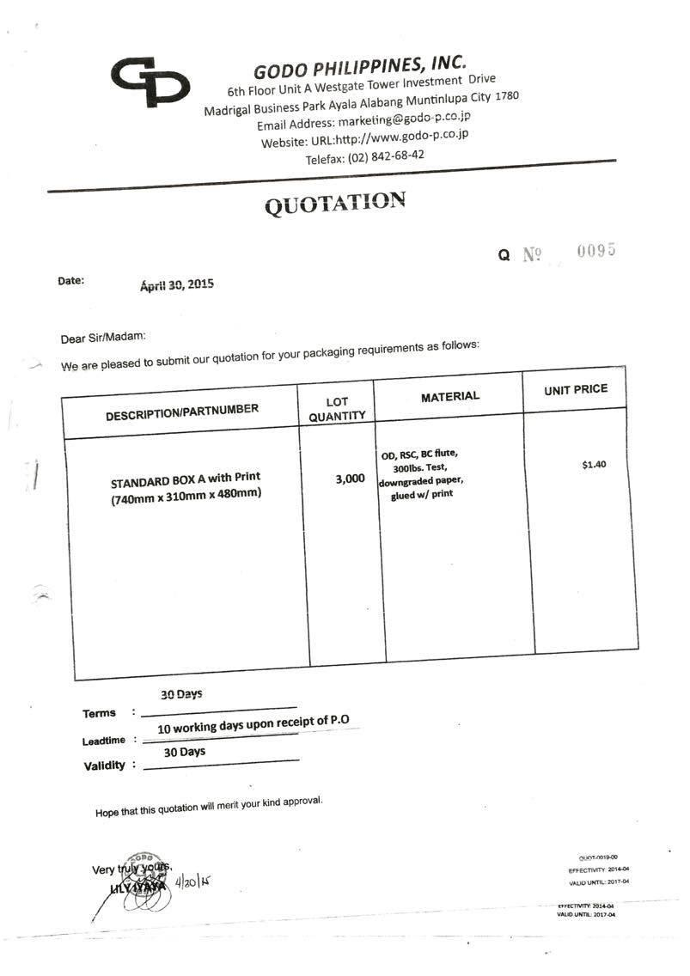

*C-2. Purchase Order Slip (Other Companies)*

*After the companies send the quotes to the clients, there will be a bidding . If the company won, the client will send a purchase order slip.*

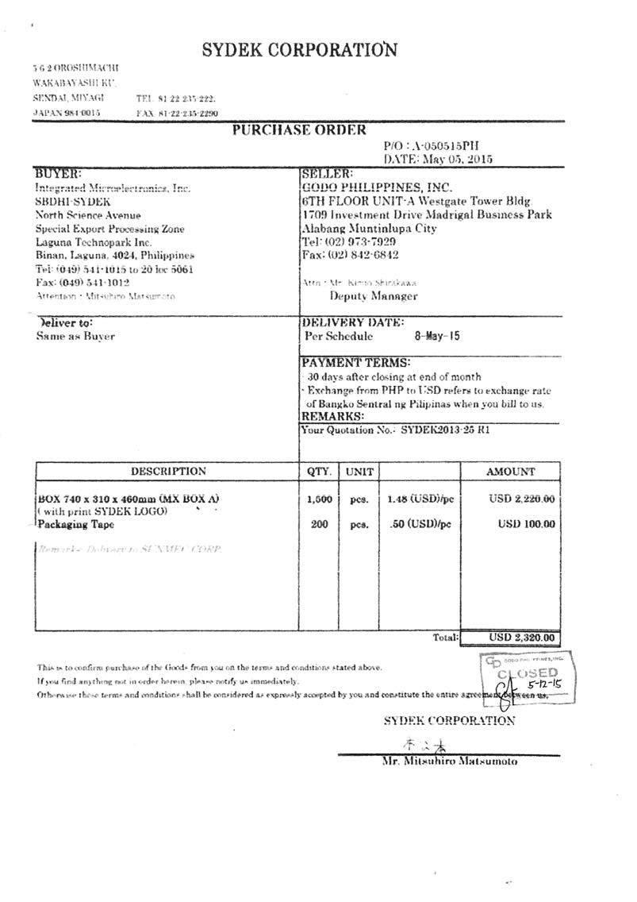

*C-3. Purchase Order Slip (Godo Philippines)*

*After the said purchase from the other companies, GODO will now find suppliers that will match the deal. When there is a match, this will be in the form of purchase order slip.*

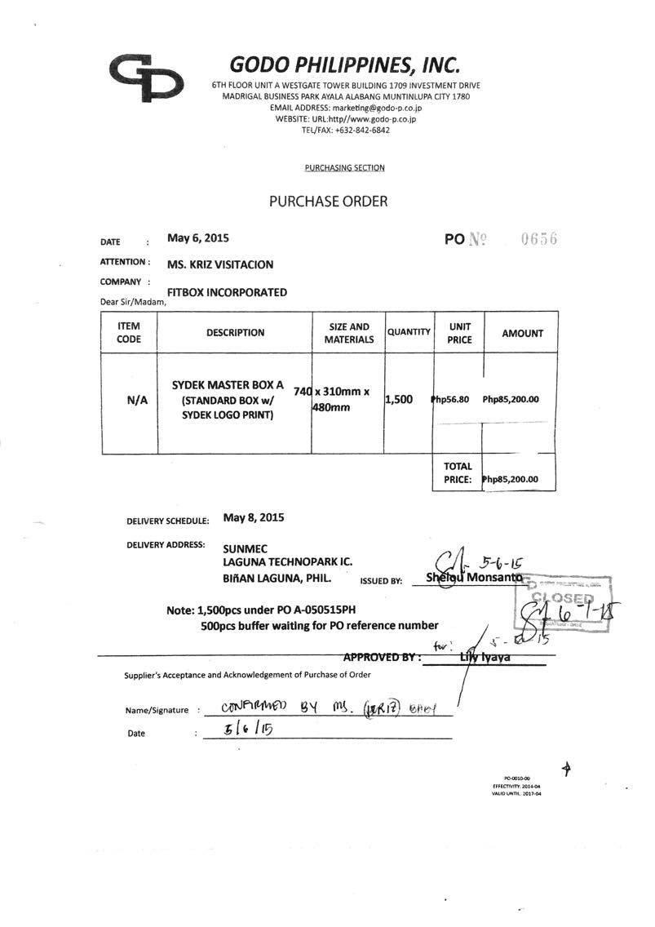

*C-4. Corrective and Preventive Action Report Form*

*Once the supplier is chosen, GODO checks in the components of the product that will be made by the suppliers in the form of a MSDS and test report form which will be sent to the client before the start of the mass production.*

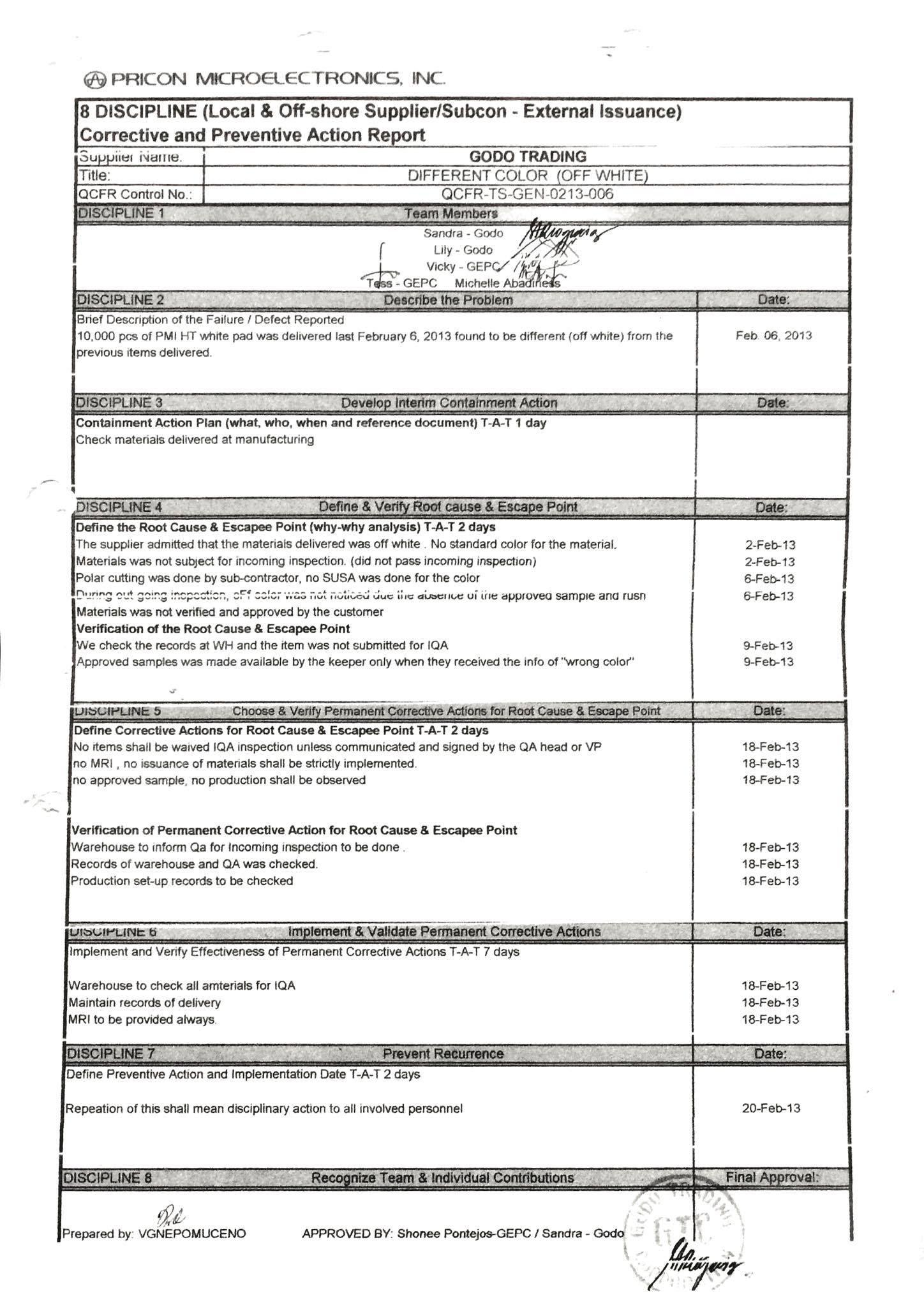

*C-5. Delivery Receipt*

*Once the products are made, the company sends a delivery receipt to the client which contains the product that will be delivered except for the price because of security reasons.*

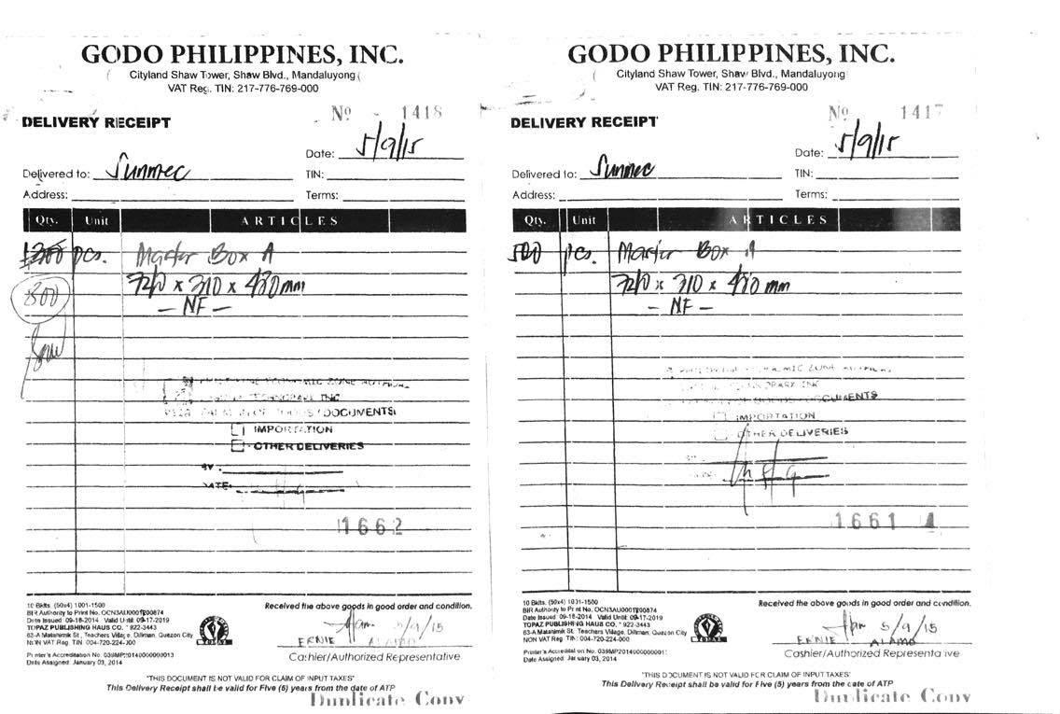

*C-6. Sales Invoice*

*Once the client acknowledges the delivery receipt, GODO will send an invoice that contains the price of that particular delivery.*

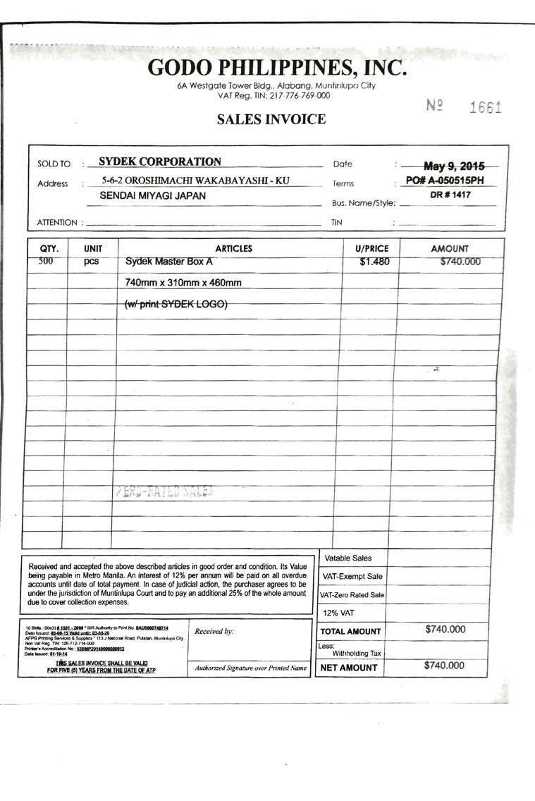

*C-7. Delivery Monitoring Report (Monthly and Weekly)*

*Every successful transaction of delivery, GODO compiles all the transaction which is weeks and months to monitor the accounts of the client and the supplier.*

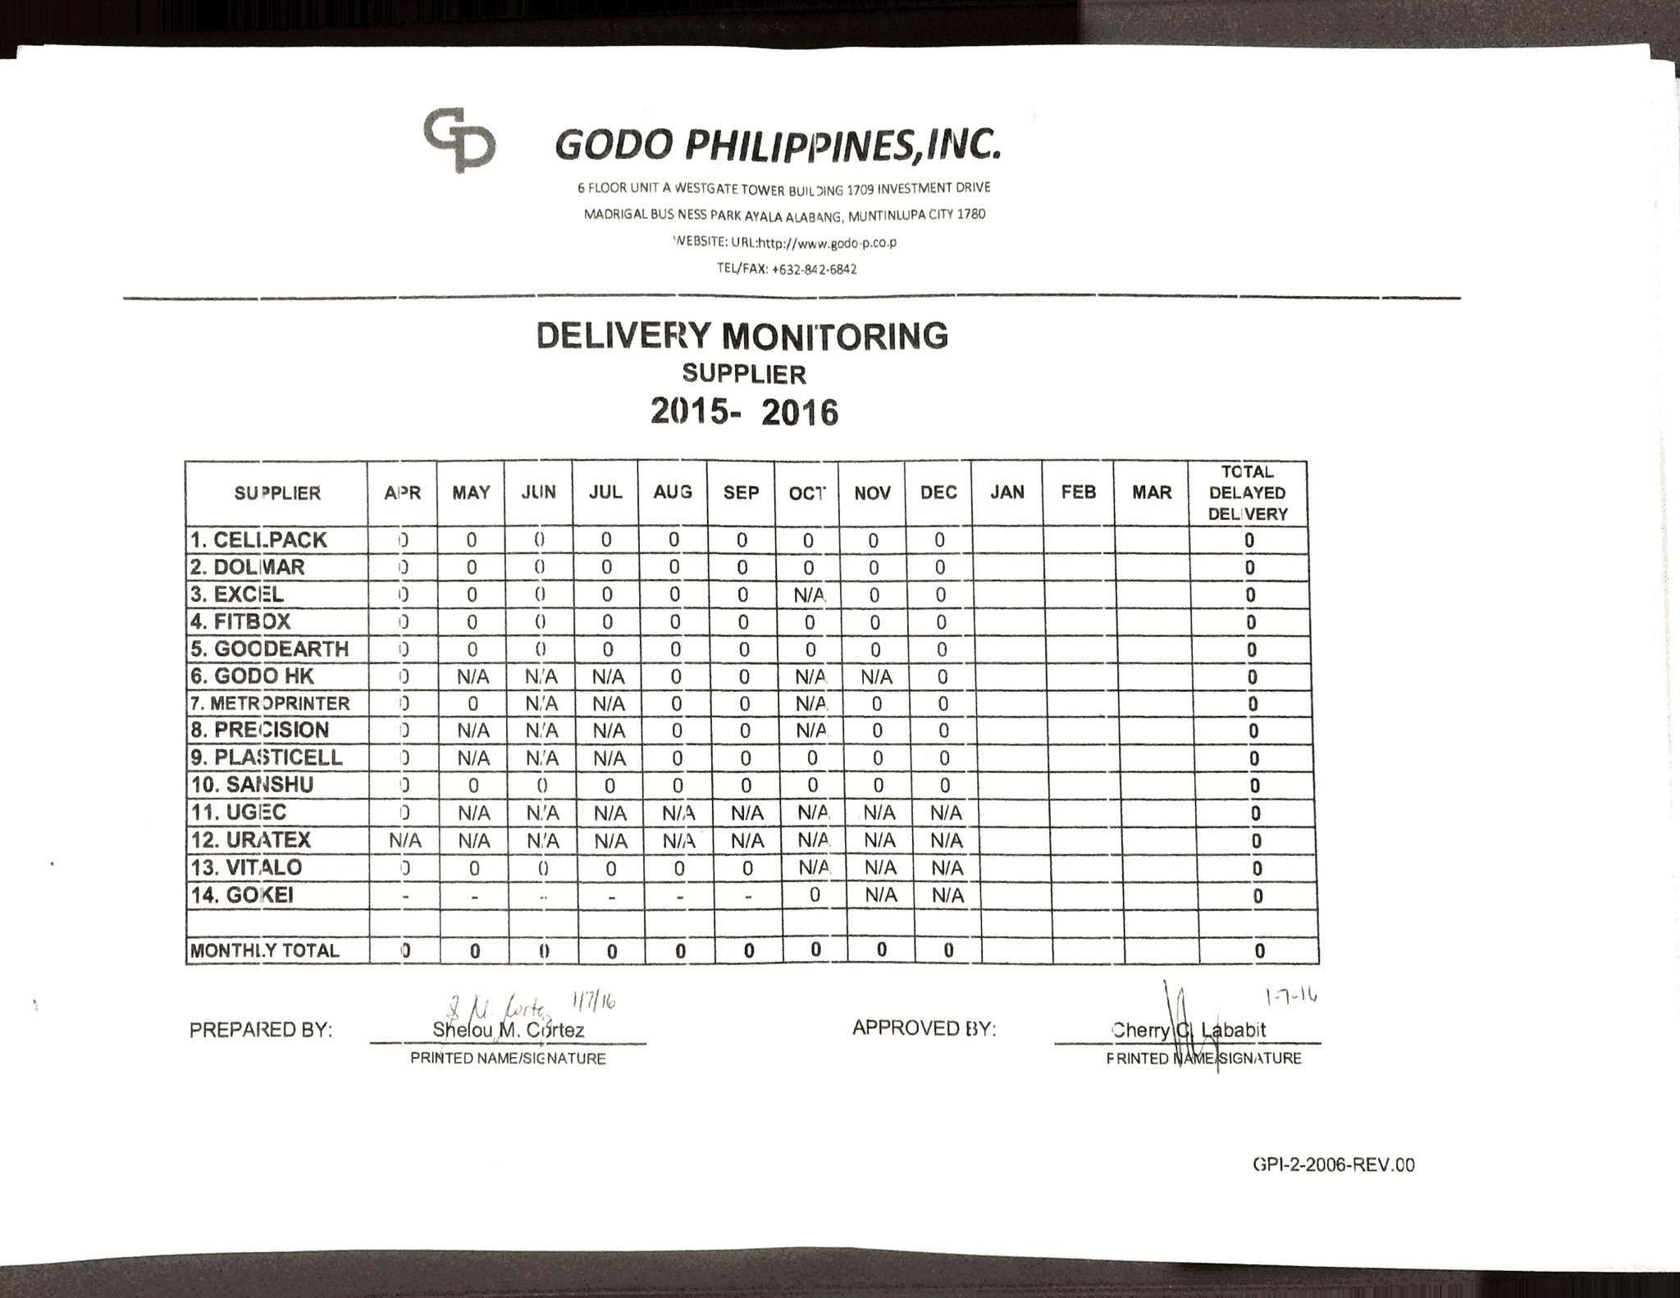

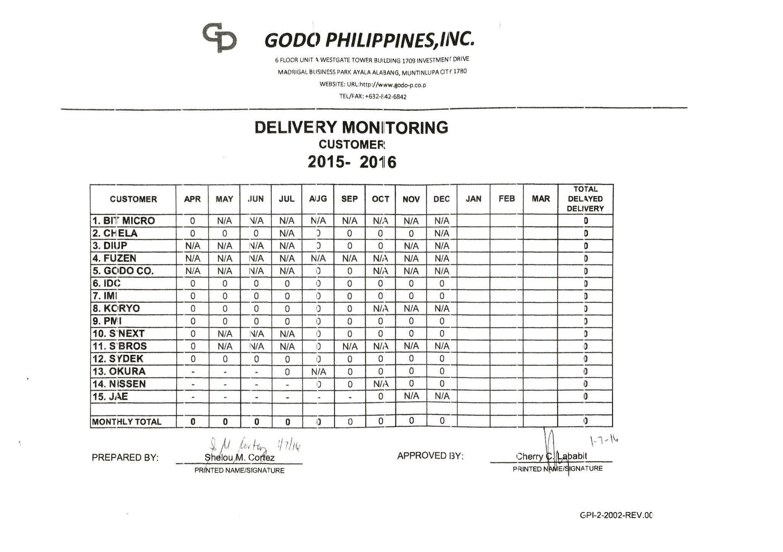

*C-8. Quality Complaint Feedback Report Form*

*Every unsuccessful transaction, the client sends the form through the company to the supplier which contains how much product needs to be reproduced.*

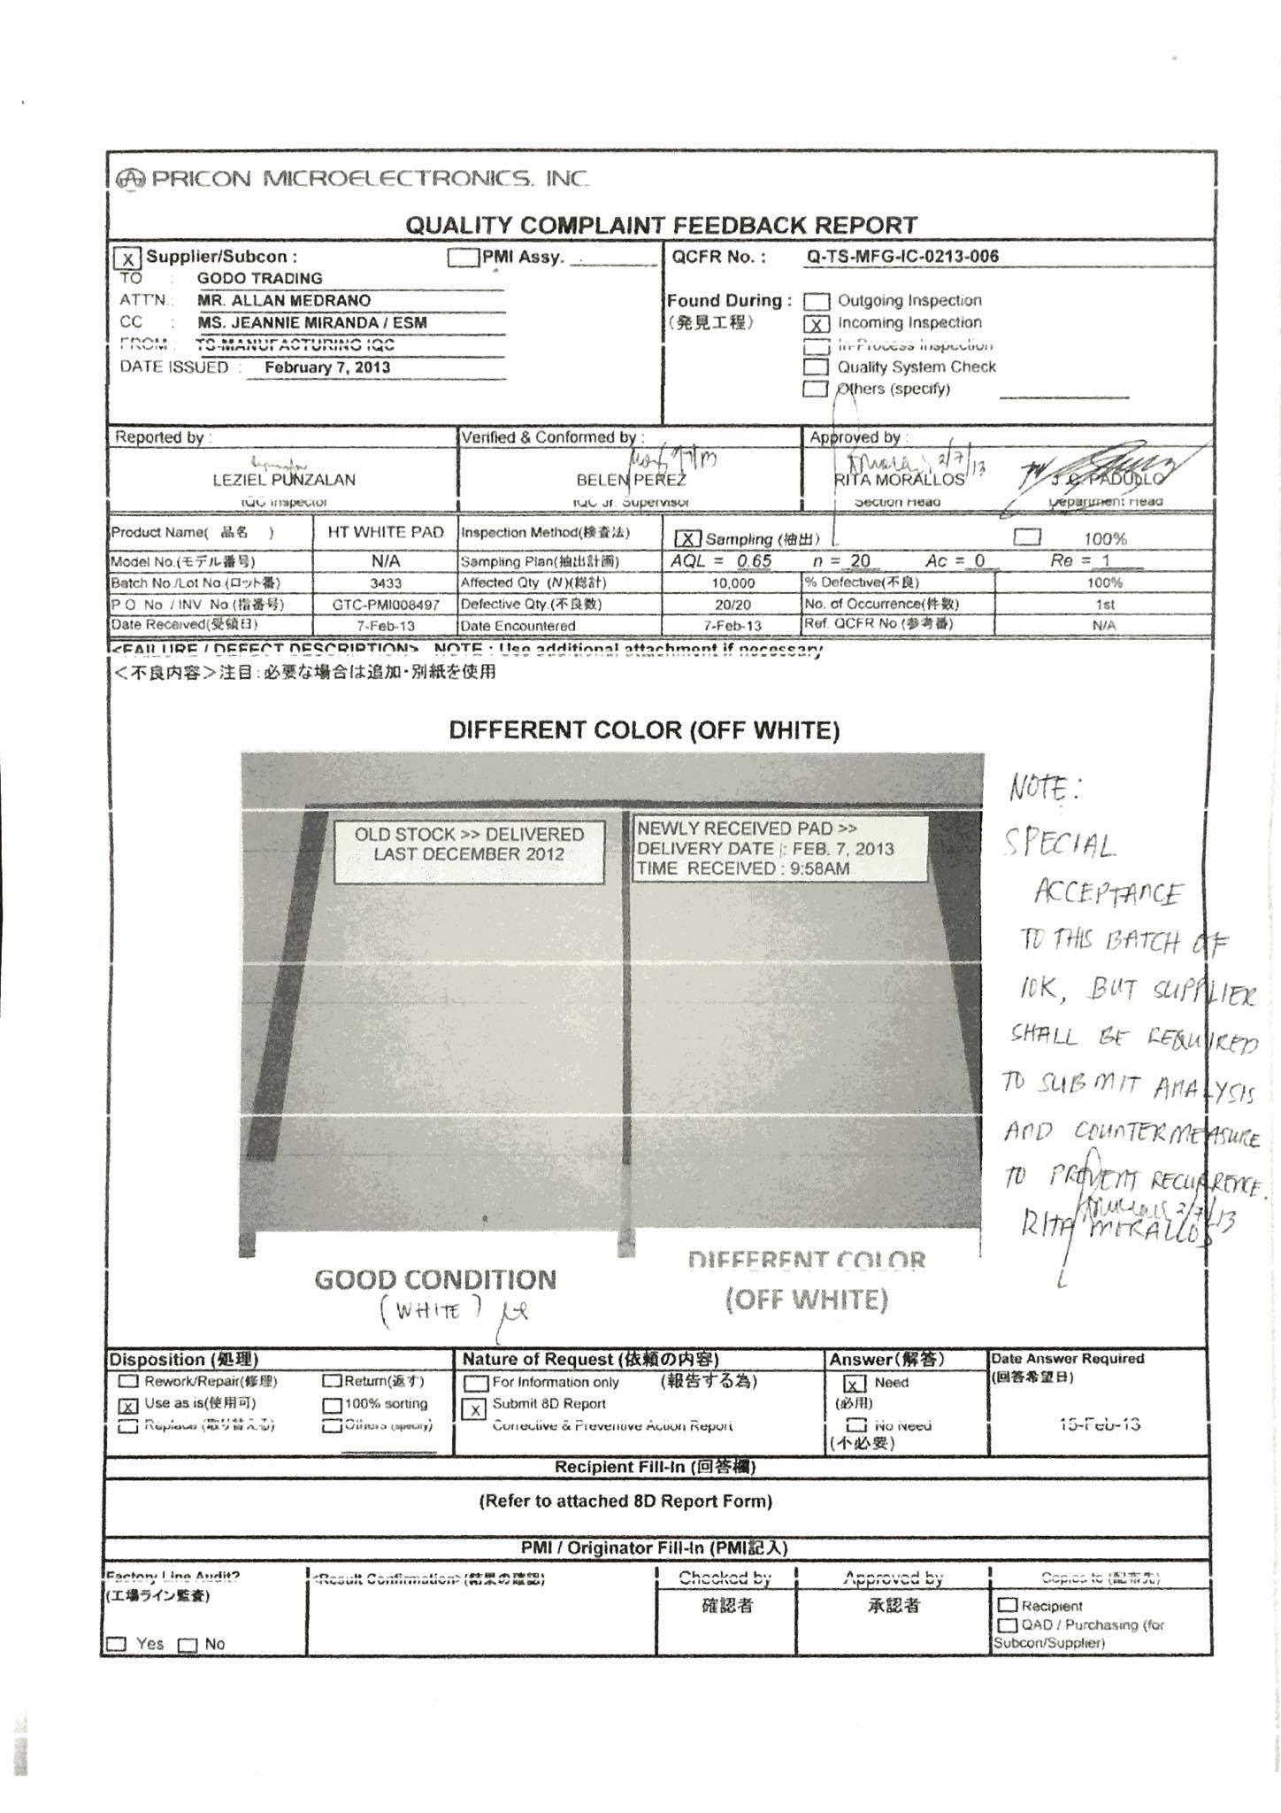

*C-9. Summary of Billing*

*Godo Philippines keeps track of the ordered materials of the client.*

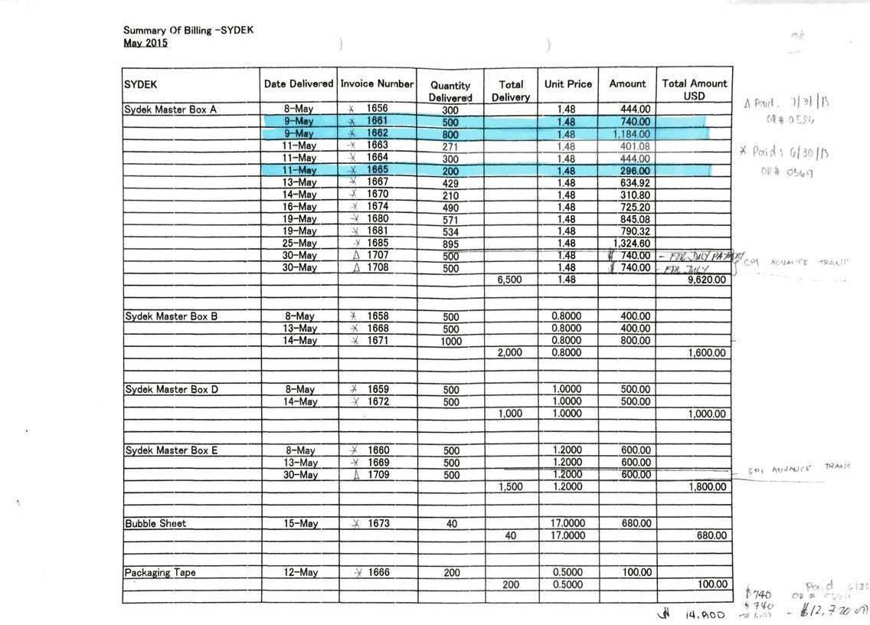

**Appendix D – References and Acknowledgement**

GODO Philippines Company

Ms. Sandra T. Deogracias, Manager